**Review Worksheet: Peripheral NS Motor Division, and Reflexes**

Name: ……………………………………

*Do these questions, using your learning resources. Look at the “marks” to give you an idea of the level of detail required in the response (formative only – does not count towards your grade). At the end, mark your work, correct it, and fill in the reflection section. Questions marked * require you to use reasoning, inferring and application of knowledge, or perhaps extra research to get the answer. It won’t be right there in the text.*

1: State the function of the motor division of the PNS and name the two main subdivisions:

(2 marks)

*………………………………………………………………………………………………………….*

*………………………………………………………………………………………………………….*

*………………………………………………………………………………………………………….*

2: What type of tissue is controlled by:

1. The **somatic** motor PNS –  *……………………………………………………………*(1 mark)
2. The **autonomic**motor PNS – …………………………………………………………(1 mark)

3: What are the two subdivisions of the autonomic motor PNS?

(2 marks)

*……………………………………… ……………………………………..*

4: Which subdivision of the PNS do I belong to? (6 marks: 0.5 per correct answer)

“I release ACh at the tissues and have no synapses outside of the CNS” …………………………….…………

“I release ACh at the ganglion synapse, then NAdr (NEpi) at the tissues” ………………………………..……..

“I release ACh at the tissues and my neurons have one synapse outside of the CNS”…………………………

“My synapses outside of the CNS are organised in ganglia close to the spinal column” ………………………

“My neurons outside of the CNS are pseudounipolar”……………………………………

“I release ACh at ganglia close to the effector tissue”……………………………………

“I release ACh at a gland that produces Adr and NAdr”………………………………….

“I connect to the spinal cord via the dorsal root”…………………………………………...

“I am often under voluntary control” …………………………………………………………

“I run through the ventral roots of the spinal cord along most of the vertebral column and have one synapse outside the CNS”…………………………………………

“My cell bodies are in the dorsal root ganglion”…………………………………………

“My neurons exit the spinal column mostly from the brainstem, and the base of the spinal cord, not from between vertebrae”………………………………………………….

5: Define the term “reflex” and list the four properties of reflexes

(5 marks)

*………………………………………………………………………………………………………………..*

*……………………………………………………………………………………………………………….*

*……………………………………………………………………………………………………………….*

*……………………………………………………………………………………………………………….*

*……………………………………………………………………………………………………………….*

*……………………………………………………………………………………………………………….*

6: What is the function of reflexes?

(2 marks)

*……………………………………………………………………………………………………………….*

*………………………………………………………………………………………………………………*

7: Draw in a reflex arc on the diagram below, and label all structures and features.

(12 marks)

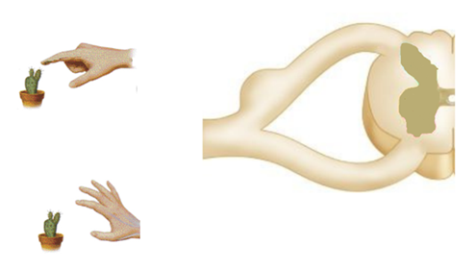

8: Draw an annotated flow diagram showing regulation of cortisol production in the body. (6 marks: 0.5 marks per feature)

Go back and mark your work using the marking key provided. What score did you get? /37

*I included enough detail and scientific terminology in my answers.*



*I was able to find information in the text/powerpoint presentation.*

*I was able to reason and infer where the information wasn’t directly in the text (questions with *).*

*I marked my work and wrote down any answers where I missed marks.*